Project Title
Automated Network Request Management in
ServiceNow

Name: Gonimilli Susmitha
College: Chalapathi Institute of Engineering and Technology
Email: y23cse049@chalapathiengg.ac.in
Project overview :
The Automated Network Request Management in ServiceNow project focuses on simplifying andaccelerating the handling of network -related service requests. By leveraging ServiceNow’s servicecatalog, workflows, and automation capabilities, the solution eliminates manual bottlenecks and ensurerequests are processed efficiently. End users can easi ly submit requests through a self -service portal,while automated routing, approvals, and task assignments streamline fulfilment. Where possible,integration with network automation tools enables end -to-end execution without human intervention.This results in faster turnaround, improved SLA compliance, and enhanced transparency for both usersand IT teams.

Table of Contents:
1. Introduction
2. Project Objectives
3. Key Features
4. ServiceNow Developer Setup
5. Project Implementation in ServiceNow
6. Screenshots of Output
7. Conclusion

1) Introduction:
Modern enterprises rely heavily on robust and efficient network services to support day-to-day businessoperations. As organizations grow, the demand for network -related requests —such as accessprovisioning, configuration changes, and connectivity support —also increases. Traditional manualrequest handling often leads to delays, errors, and limited visibility, impacting both productivity and usersatisfaction.
To address these challenges, the Automated Network Request Management in ServiceNow project introduces a streamlined solution that leverages ServiceNow’s workflow engine, service catalog, andautomation features. By enabling end users to submit requests through a self -service portal andautomating approvals, task assignments, and notifications, the system ensures faster, more accurate, transparent request management.
This initiative not only enhances the user experience but also empowers IT teams by reducingrepetitive tasks, improving SLA compliance, and allowing focus on strategic, high-value activities.

2) Project Objective:
This project aims to design and implement a streamlined, automated solution for managing network related service requests within ServiceNow. It enables end users to submit requests for network services through a user-friendly self-service portal.
The system leverages ServiceNow’s workflow engine, catalog items, and approval processes to ensurerequests are properly captured, validated, and routed for fulfilment. Upon submission, requests triggerautomated notifications, task assignments, and—where applicable—integration with network automation tools or scripts to fulfil standard requests without manual intervention.

3) Key Features:
- Custom service catalog for common network requests
- Dynamic forms to capture relevant request details
- Automated approval workflows based on request type and sensitivity
- Integration with infrastructure management or orchestration tools (optional)
- Real-time status updates and notifications to requesters and technicians
Reporting and analytics on request volume, resolution time, and SLA adherence

4) ServiceNow Developer Setup:
Create a Developer Account
1. Go to ServiceNow Developer Portal(https://developer.servicenow.com/dev.do).
.Sign up for a free developer account and fill out the following details.
2. After signing up, you will get a verification mail to your provided email id. After the verification your ServiceNow Developer Portal Home Page will appear.
3. Now click on start building it will take you to the section where you can request a Personal Developer Instance (PDI) or start using App Engine Studio and other tools.
4. Profile Icon (Top Right Corner) → Manage your account, request instances, and check your developer profile.
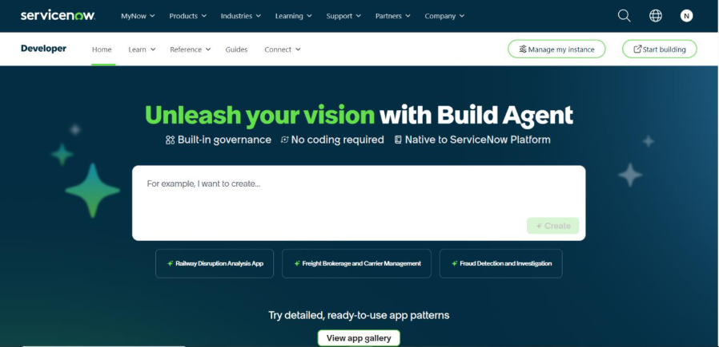

5) Project Implementation in ServiceNow:
After the instance building is completed, the page will be directed to your creator studio. Creator Studio in ServiceNow provides a guided, no-code environment to build applications quickly. It is especially useful for creating request -based applications by defining forms, setting up tables, andautomating workflows.

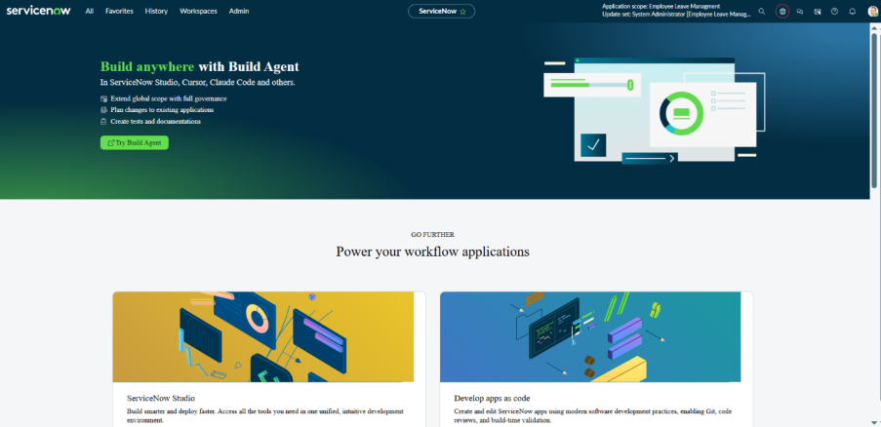

a. Service Catalog Creation:
i. Creation of Service Catalog
1. Navigate to Application navigator
2. Click on All → search for Service Catalog
3. Under Service Catalog → Maintain items
4. Click on New
5. Fill the details → Name– Network Request
6. Select Catalog → Service Catalog
7. Select Category → Network
8. Fill the Short Description as Network request Management
9. Click on Save.
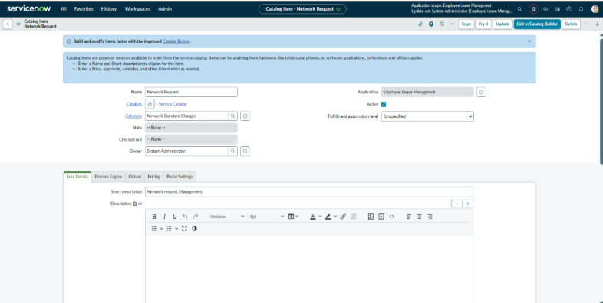

ii. Variables Configuration
Open the catalog item just created.
Scroll down to the Variables related list and click New to create form fields.
1. Select Variables type as Single, Multi line text, reference, choices etc as per
requirement
2. Catalog item – Network Request
3. Order–100, 200, 300, …
4. Question– provide the variable label
5. Name–provide the variables name (used for scripting)
6. Tooltip– this will appear when cursor overed on the field
7. Example text – this will suggest what we need to enter on the field.
8. Mandatory, read-only – need to configure on demand.
9. Auto populate– need to select dependent variable, apply dot walking to get
Selected value.
10. Click on Save or Submit.
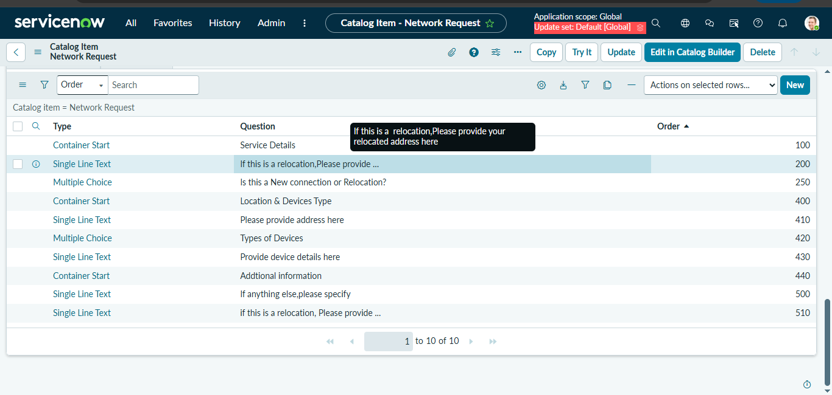

iii. Variables Types
1. Is this a new connection or Relocation? → Choice → New/ Relocation/None
2. If this is a relocation, please provide your relocated address here → String
3. Types of devices → Choice → Laptop/Mobiles/Others
4. Please provide address here → String
5. Provide device details here → String
6. If anything, else please specify → String
iv. Variable Set Configuration
To enhance form usability:
- Navigate to the Variable Sets (optional).
- Follow the same procedure as we used for Variables Creation, for the variable set as well.
- Apply variable sets to the catalog item.

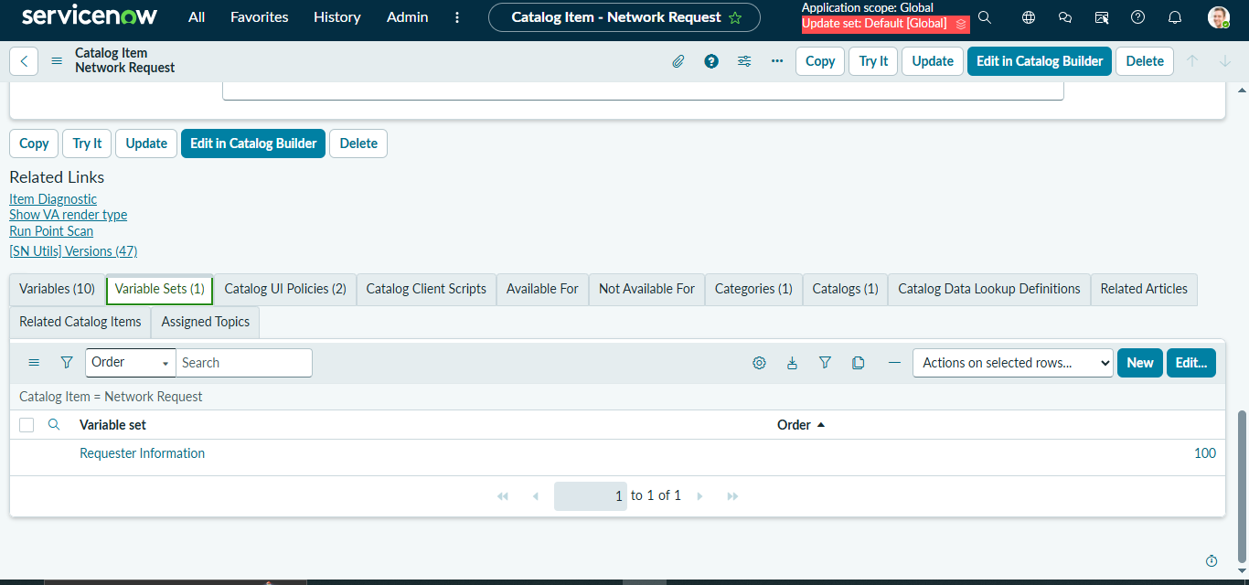

Variables Types
1. Opened on behalf of → Reference → Reference to user table
2. Email Id → Single line text → Auto populate by Opened on behalf of variable.
3. User name → Single line text → Auto populate by Opened on behalf of variable.
4. Phone Number → Single line text → Auto populate by Opened on behalf of
variable.
5. Proof of Document → Attachment

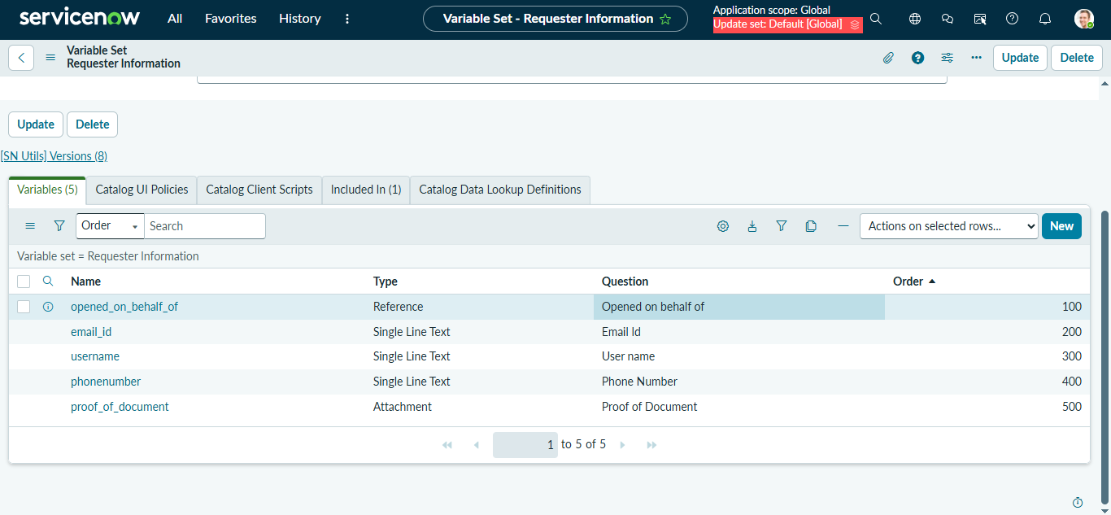

v. Catalog UI Policy Configuration
Scenario: If user selects types of devices is Others, then Please specify field should populate.
Procedure:
1. Navigate to catalog items
2. Open Network Request item
3. In related list, we have Catalog UI policy
4. Click on New button to configure New UI policy
5. Select Applies to as Catalog item
6. Select catalog item as Network Request
7. Provide short description, if required
8. Apply condition → types of devices is others
9. Click on save, after saving the form will get UI policy actions in the related list
10. Click on New button to configure new UI Policy action, and Select the variable
which we want to display on condition
11. Make Visible True as per our requirement
12. Update the UI Policy and Test the same on Catalog form

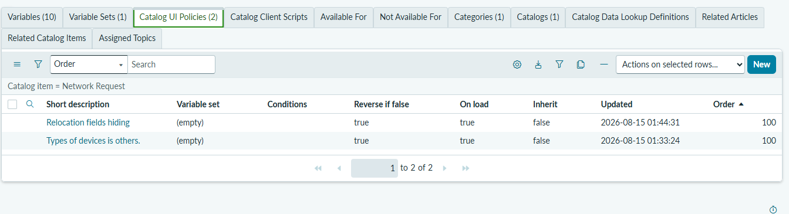

b. Creation of Table:
i. Creation of Table
Navigate to: System Definition → Tables.
a. Click New to create a new table.
b. Fill in Table Information:
i. Name: Name of the table
ii. Label: Backend name of the table
iii. Auto-generate schema: Leave it checked if you'd like ServiceNow
to auto-generate schema fields.
c. Click Submit to create the table.
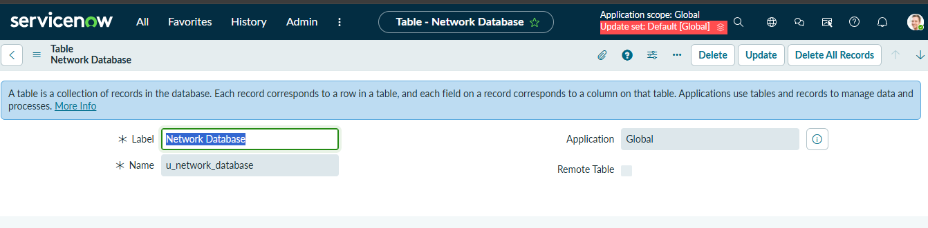

ii. Creation of Fields
Fields are created at the table level in ServiceNow.
1. Open Application Navigator and search for Tables.
2. Go to System Definition → Tables.
3. Search for and open the Network Database table.
4. Open the Columns section.
5. Click New to create a new field.
6. Enter the required field details and click Submit.
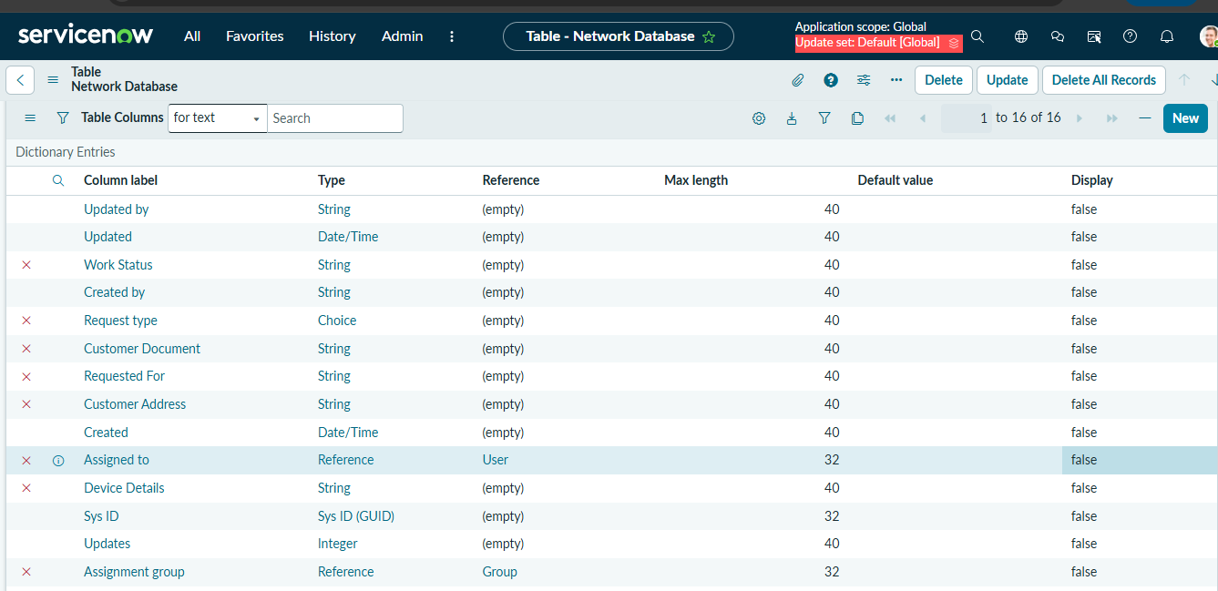

c. Request Approvals Creation (Related List):
i. Creation of Related List
1. Navigate to System Definition → Relationships.
2. Click New to create a new relationship.
3. Fill in the following details:
• Name: Approval Request
• Applies to Table: Network Database table.
• Queries from Table: Sysapprovals table.
• Active: Make sure it's set to True.
4. Save the relationship.
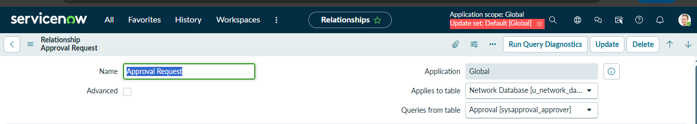

ii. Adding Related List to the Table
1. Navigate to Form Designer for the table where you want to show related records.
2. Add a Related List widget to the form.
3. Select the Related List you want to show

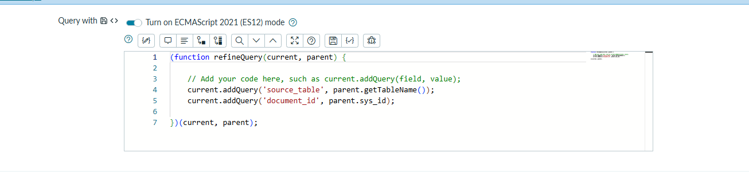
d. Creation & Implementation of flows, Actions in Flow Designer :
i. Creation of Flow
1. Navigate to Flow designer home page
2. Click on New to create a new flow
3. Provide flow name as Network Request
4. Provide description of flow
5. Click on Build flow.

ii. Configuring Trigger
1. Click on (+) Icon to Configure the Trigger
2. Select Trigger as Application → Service catalog
3. Click on Done.
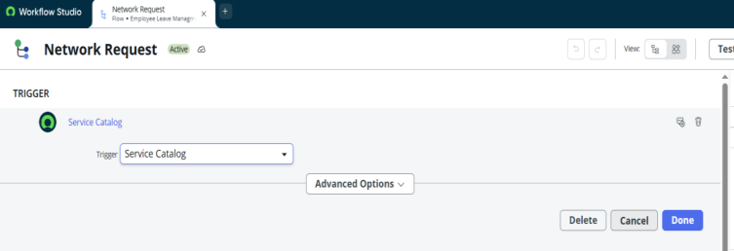
iii. Configuring Actions
Click on Actions button to configure new action
1. Get Catalog Variables
- Click on Action, search for Get Catalog Variables
- Select Get Catalog Variables
- Action Inputs → Trigger → service catalog →Requested Item
- Template catalog items → Select table → Network Request
- Select the Required Variables and Move to the selected area.
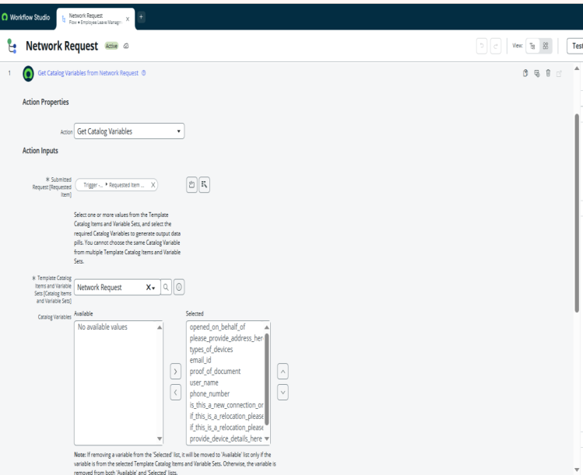
- Click on done

- 2. Create Record
- Select action as Create Record
- Select table as Network Database
- Click on Add fields button to configure the fields
- Configure the Required fields as shown in the below picture
- Click on done

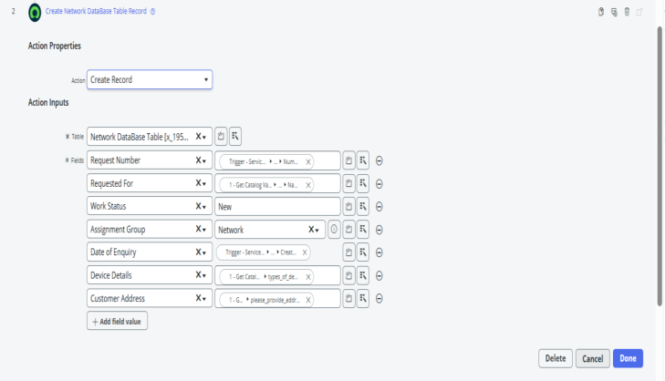

3. Ask for approvals
- Select action as Ask for Approval
- Select target record → Create record → network database table
- Provide Approval Reason → Waiting for approval
- Configure approval rules → Approve, reject, approve/reject
- Select approvals as Anyone approves, everyone approves etc.
- We can select approvals like static/dynamic as shown below
- Click on done

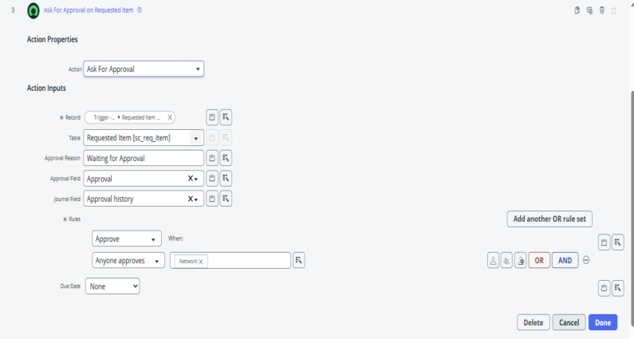

4. Flow Logic
- Select action as flow logic and Select If condition
- Apply condition → Ask for approvals state is Approved/Rejected as per requirement
- Click on done

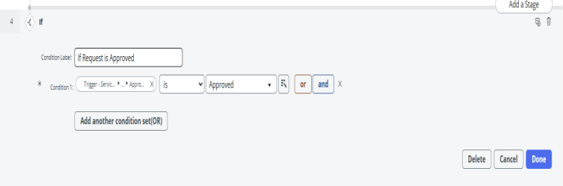

5. Send Email
- Select action as Send Email
- Select target record → Create record → network database table
- Table will be selected automatically
- Configure To, CC, BCC as per our requirements (select static/dynamic)

- Provide Subject & Body as shown in the below picture
- Click on done

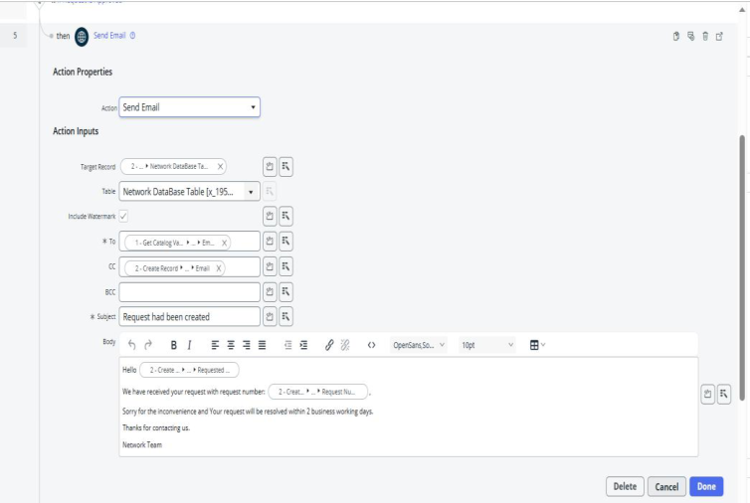

6. Update Record
- Select action as Update Record
- Select record as → create record → network database
- Table will be selected automatically
- Configure the fields as per requirement, as shown in below
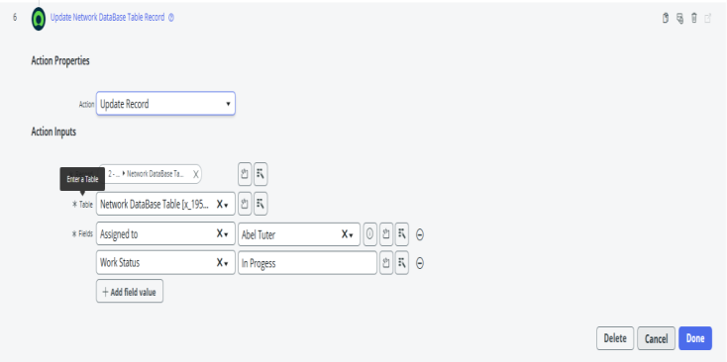
- Click on done

iv. Flow Chart

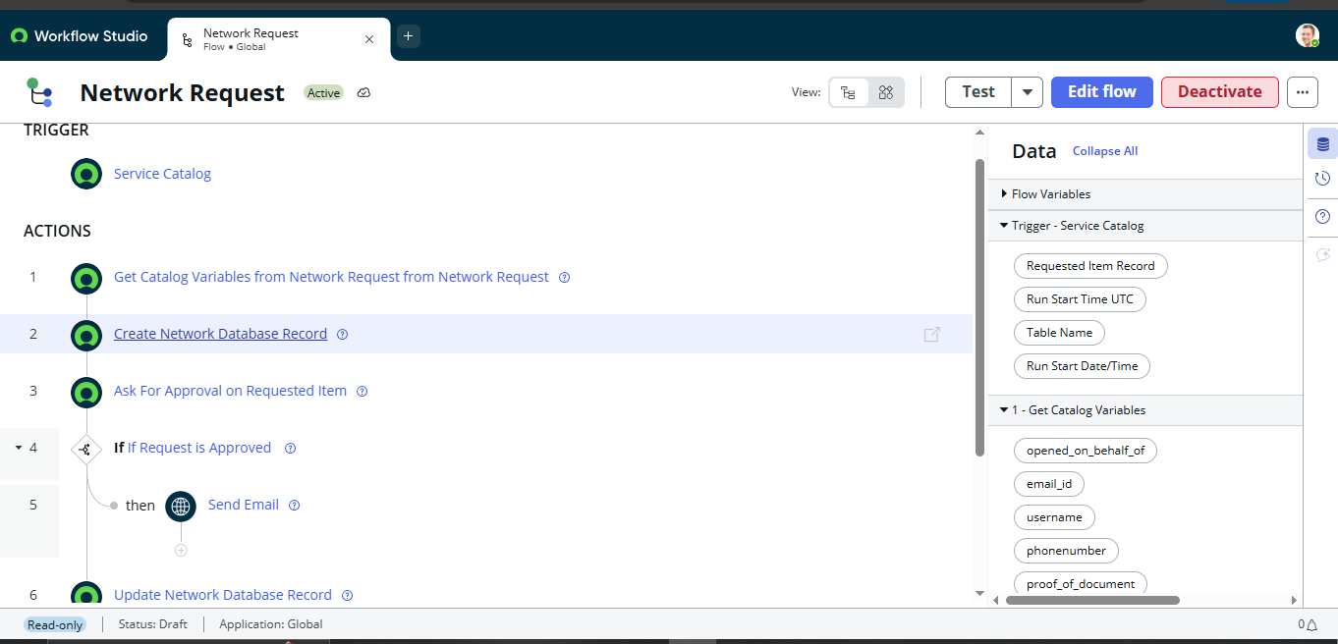

Network Request Workflow: -
The Network Request workflow automates the complete request process in ServiceNow. When a user submits a request through the Service Catalog, the flow retrieves the submitted details, creates a Network Database record, and sends the request for approval. If the request is approved, an email notification is sent and the Network Database record is updated automatically.
Workflow sequence:
Service Catalog → Get Catalog Variables → Create Network Database Record → Approval → Send Email → Update Network Database Record

6. Screenshots of Output:
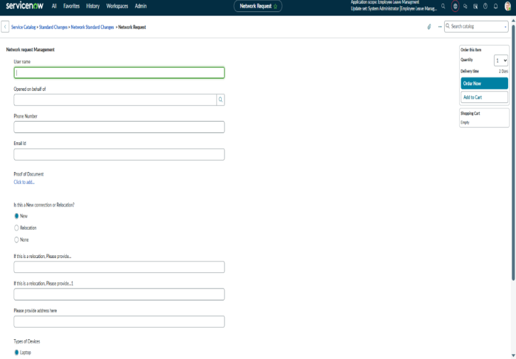

Fig: Network Request Service Catalog Form

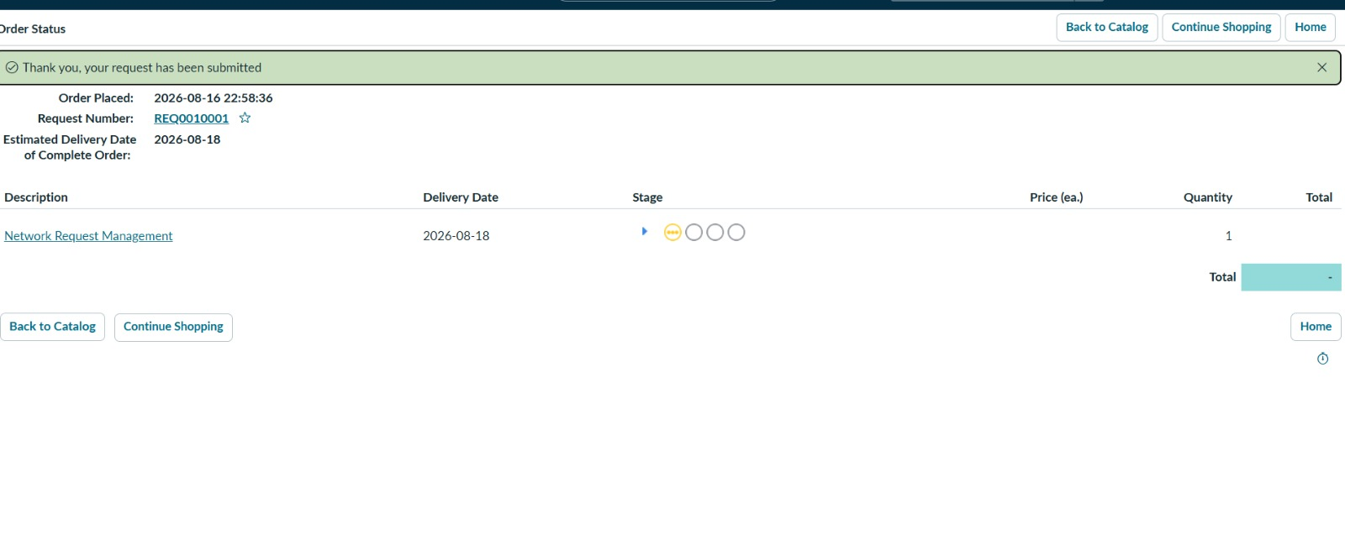Fig: Network Request Order Status

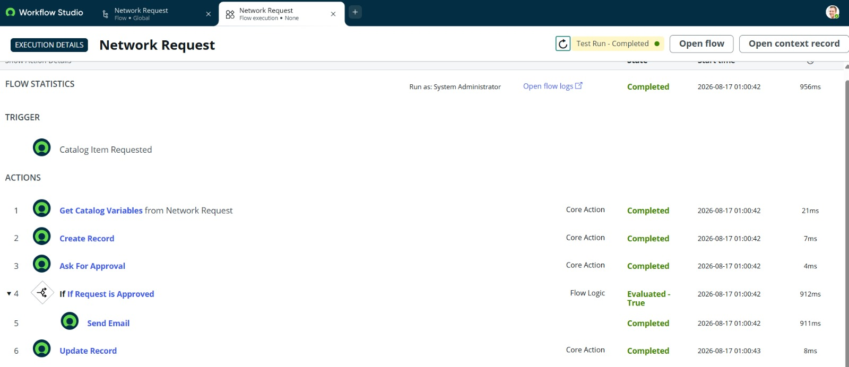
Fig: Testing Flow Execution

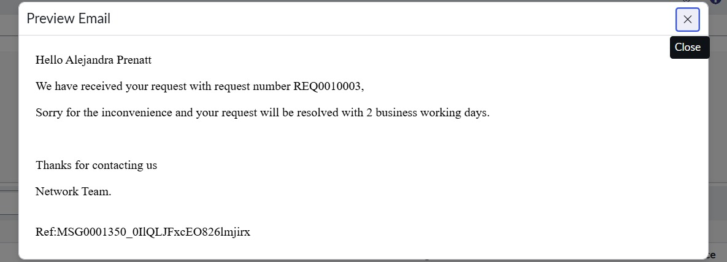
Fig: Preview of Email Notification

7. Conclusion:
The Automated Network Request Management in ServiceNow project successfully provides a centralized and automated approach for managing network service requests. The solution enables users to submit requests through the Service Catalog, capture the required information, and move requests through approval and processing in a structured manner.
By using Service Catalog and Flow Designer , the project reduces manual effort and improves the consistency of request handling. Automatic record creation, approval processing, status updates, and email notifications provide better visibility for both requesters and support teams.
Overall, the project demonstrates how ServiceNow can be used to build a simple, efficient, and scalable network request management solution that improves request tracking, reduces unnecessary follow-ups,and supports faster service delivery.
.
THANK YOU!

